Experiment Details

|  |  |
| --- | --- |
| Department Name | Mechanical Engineering |
| Class | TYBTech |
| Semester | 1st |
| Subject Name | Heat Transfer |
| Experiment No. | 2 |
| Experiment Name | Heat Transfer through a lagged pipe |

Version History

|  |  |  |  |  |
| --- | --- | --- | --- | --- |
| Sr. No. | Version Number | Created By | Approved By | Date |
| 1 | v1.0 | Vedant Mandrupkar | Mr. Rohit Ghulanavar | 05/11/2020 |
|  |  |  |  |  |

AIM:

To determine thermal conductivity of insulating material used in lagged pipe and plot the radial temperature distribution.

THEORY:

Many engineering applications related to heat transfer need insulation over a pipe or cylinders. Popular examples are steam pipe, electrical wires, hot water pipes refrigerant pipes etc. In these cases the pipe is lagged with insulation material like asbestos, glass wool, plastic etc. It is necessary know the effect of thickness of these insulation and temperature distribution before using them. Thermal conductivity of these materials play important role in minimizing and increasing heat transfer rate.

Thermal conductivity is defined as the ' rate of heat transfer by conduction per unit area per unit temperature gradient' and its S.I unit is W/mK or W/m℃. While calculating the thermal conductivity experimentally Fourier's law of heat conduction is used. It can be stated as: **'Rate of heat transfer by conduction in steady state is directly proportional to the normal area and temperature gradient'.**

Mathematically, Q ∝ A*dT/dx;

Where, Q = heat transfer rate in W

T = Temperature in ℃ or K

A = Area normal to heat transfer in sq.meters

Removing proportionality the law can be written as, Q = -kA*dT/dx;

Where, k = constant of proportionality called as 'Thermal conductivity'. Negative sign here indicates that the there is decrease in temperature in the direction of heat transfer.

Thermal resistance can be calculated using electrical analogy as given below.

Heat transfer rate = (Thermal potential difference) / (Thermal resistance); Q = ΔT/Rth

Where Q is analogous to Current I , ΔT analogous to Voltage V and Rth analogous to Electrical Resistance R. S.I unit of thermal resistance is ℃/W or K/W. Expression for thermal resistance depends on the geometry for heat conduction. Rth expression for hollow cylinder is given below.

**Hollow Cylinder:** Rth = [ln(r2/r1)]/2πkL;

Where, r2 = outer radius , r1= inner radius, k= thermal conductivity and L=length of cylinder.

DESCRIPTION OF APPARATUS:

The experimental setup consists of three concentric cylinders as shown in figure. The gap between the cylinders is filled with glass wool insulation whose thermal conductivity is to be found out. Heating coil is inserted inside of inner cylinder. With the help of dimmerstat heat input can be controlled. Voltmeter, Ammeter and Selector switch with temperature indicator are provided on the console. K-type thermocouples are used for measuring temperature. Three thermocouples each are used at four different radii.

DIAGRAM:

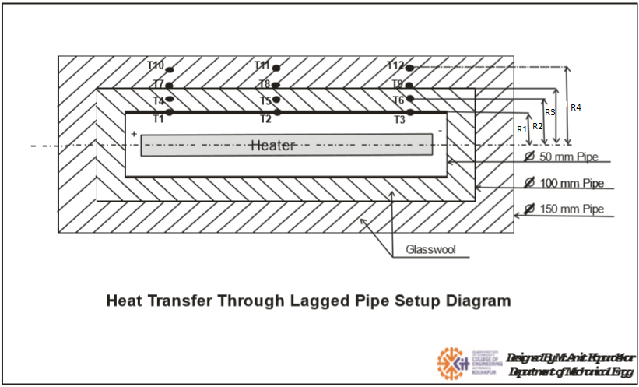

SPECIFICATIONS:

1. M.S. Pipe (1) : 50mm I.D

2. M.S. Pipe (2) : 100mm I.D

3. M.S. Pipe (3) : 150mm I.D

4. Location of thermocouples in the insulation: r1=28mm, r2=37.5mm, r3=53mm, r4=62.5mm

5. Heater Coil: 500 W

6. Dimmerstat: 2 - 5 kW

7. Voltmeter: 0 - 300 Volts

8. Ammeter: 0 - 5 Amperes

9. Multi channel digital temperature indicator: 0 - 400°C

10. Thermocouples: k-type (12 Nos.)

11. Length of pipe= 500 mm

PROCEDURE:

1. Enter Voltage and Current values. Voltage entered must be between 1 to 300 Volts and current must be between 0.01 to 5 Amperes.
2. After entering voltage and current, run the simulation and note down temperature values.
3. Calculate thermal conductivity of Glass wool by using formulae given.
4. Take readings minimum 4 times.
5. Find Average thermal conductivity of glass wool = k
6. Plot the radial temperature distribution T v/s Radius
7. Compare the thermal conductivity of glass wool obtained with its standard value.

OBSERVATION TABLE: 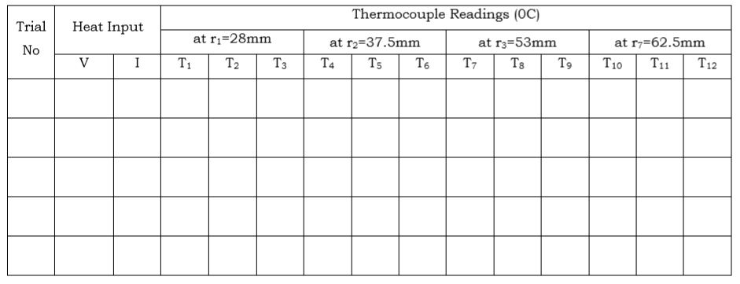

RESULT TABLE:

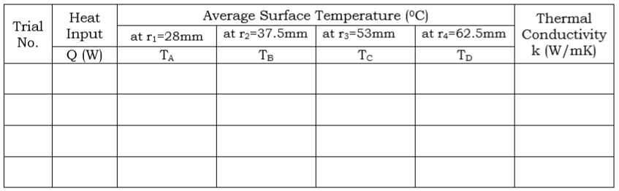

FORMULAE:

1. Heat Input = Q = V x I (W)

2. Average surface temperatures:

Ta = (T1+T2+T3)/3

Tb = (T4+T5+T6)/3

Tc = (T7+T8+T9)/3

Td = (T10+T11+T12)/3

3. Thermal Conductivity of Insulating Material:

Q = ΔT/Rth = (Ta-Td) / [ ln(r4/r1)/2πkL ]; therefore k = [Q*ln(r4/r1)] / [2πL*(Ta-Td)]

PRACTICE QUESTIONS:

1. What do you mean by lagged pipe?

2. Give examples for lagged pipes.

3. What do you mean by critical radius of insulation?

4. Write expression for critical radius of insulation for cylinder and sphere.

5. What do mean by diffusivity? Give its significance and SI units.

6. Shown in figure the plot of T vs L for heat conduction. Which has more thermal conductivity and why?

